Meeting detail | Information
Date | 15/05/2026
Time | 9am to 6 pm
Group number | B(power rangers)
Chair | Six
Minute-taker | Sujal pathak
Agenda item | Notes
Confirm prototype scope | The group decided to create a simple cyber-safety game prototype with a welcome page, game instruction
Divide prototype tasks | Five people work on the welcome screen and instruction page by dividing the different part
Start building Prototype Version 1 | The group created the HTML file
Upload evidence to GitHub | Screenshots, HTML files and planning documents were uploaded to the Week-2-Prototype-Start folder in GitHub.
Plan testing | The group tested all buttons, checked whether feedback appeared correctly and reviewed readability for the target audience.
Agree next steps | The group agreed to improve the design, add more challenges, create a score system and include sound effects in the next version.
Task completed today | Student responsible | Evidence uploaded
Create welcome screen and instruction page | All members | 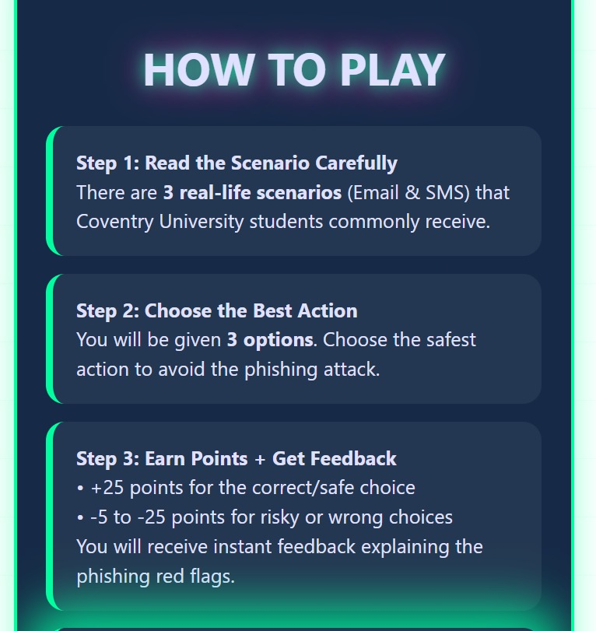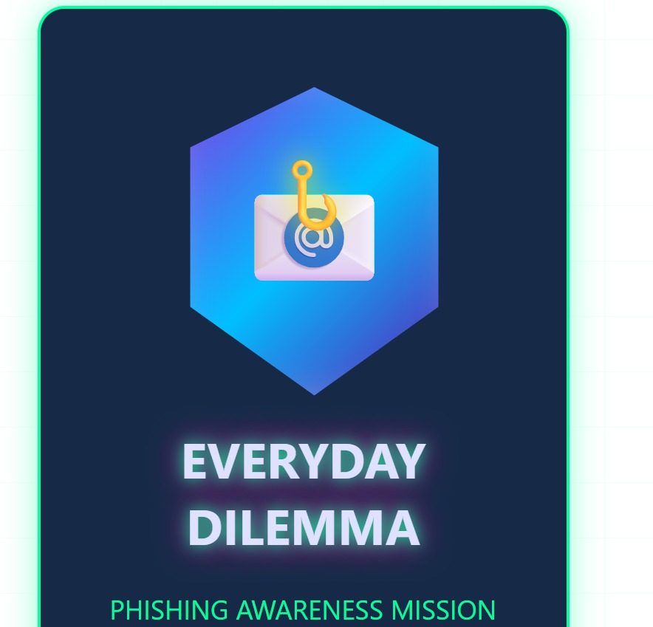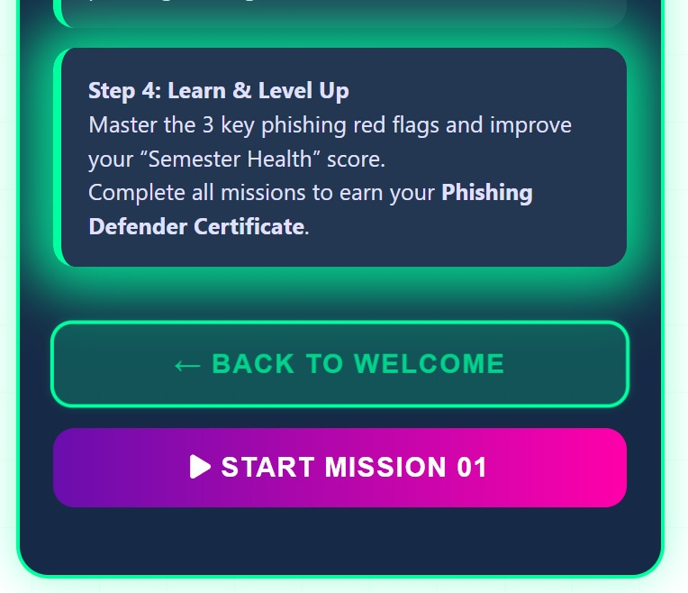
Test navigation buttons and feedback messages | All members | Testing screenshots and review notes uploaded to GitHub
Next action | Responsible student | Deadline
Improve game design | All members | Next meeting
Add more safety challenges | All members | Next meeting
Create score system | All members | Next meeting

